İSTANBUL TOPKAPI ÜNİVERSİTESİ
Faculty of Engineering
Project Report
Adı: CEN306 — Mobile Application Design and Development
Date: 15/06/2026

Students or Team Members Who Prepared the Project
Name-Surname | Signature | Student No
OMAR ASLAN |  | 22040102144
MALAK MEDHAT |  | 22040102054

Programı: Bilgisayar Mühendisliği (İng.)

(This section will be filled out by the Instructor.)
Subject of Evaluation | Evaluation Score
Flutter Mobile Application Project — Code Evaluation (70 Points)
Flutter Mobile Application Project — Project Report Evaluation (30 Points)

CEN306 - Mobile Application Design and Development
Final Exam Project Report
Project Title | OMAR Chat — WhatsApp-Style Mobile Messaging Application
Student Name-Surname | OMAR ASLAN & MALAK MEDHAT
Student Number | 22040102144 / 22040102054
Student Signature
Course Name | CEN306 - Mobile Application Design and Development
Instructor | Dr. Yıldız Karadayı
Submission Date | 15/06/2026
GitHub / Source Code Link | [Add repository URL]
Demo Video YouTube Link | [Add YouTube link]
Application Name | OMAR Chat

Academic Integrity Statement: I confirm that this report and project were prepared by me and that all external sources, libraries, code snippets, and datasets are properly acknowledged.

1. Executive Summary
OMAR Chat is a Flutter messaging application inspired by WhatsApp, developed for CEN306 by OMAR ASLAN and MALAK MEDHAT. It demonstrates direct and group chat, multi-user group creation, voice messages with contextual voice replies, photo status and profile images (including a bundled landscape photo), per-user block/unblock, sound + TTS notifications, @mention auto-replies, and full data persistence across app restarts.
The project uses layered architecture (UI / Business / Data / Services), DAO + Repository pattern, Cubit state management, and SQLite via sqflite on Android/iOS (JSON fallback on web and desktop). All chat data, messages, blocks, statuses, and profile changes persist across app restarts.
Item | Short answer
Application name | OMAR Chat
Problem addressed | Need for a structured, feature-rich chat app demonstrating mobile architecture patterns
Target users | University students, project teams (demo user: OMAR)
Core technologies | Flutter/Dart, SQLite/sqflite, flutter_bloc, flutter_tts, just_audio, flutter_local_notifications
Main contribution | Full WhatsApp-style UX with sound/TTS alerts, @mention replies, 11 screens, and clean layered architecture
2. Project Introduction
2.1 Project Purpose
OMAR Chat was developed to demonstrate CEN306 learning outcomes: layered design, persistent data storage, state management, and polished UI comparable to modern messaging apps. It simulates a multi-user environment where OMAR (user ID 1) interacts with seeded contacts through direct chats, groups, status, and calls.
2.2 Scope of the Project
Included: direct/group messaging, create new multi-user groups, voice messages with voice replies, message edit/delete, @mentions, sound + TTS notifications, search, status (24h) with default landscape photo, profile photo (gallery + bundled asset), per-user block/unblock, full data persistence, block/mute, themes, simulated calls, call history, 11 screens. Out of scope: real backend server, WebRTC, push notification server, end-to-end encryption.
2.3 Target Users and Usage Scenario
A student opens OMAR Chat, sees unread badges on the chat list, opens a group chat, types "@Ahmed can we meet tomorrow?" — Ahmed replies contextually; OMAR hears a notification sound and TTS says "Ahmed sent you a message".
2.4 Main Features
Feature | Description | Related Screen(s)
Direct & group messaging | Text, voice, files, images, drawings, emoji | Chat Detail
Create multi-user group | Name group, select members, open new group chat | Create Group, Chat List
Voice messages & replies | Record/send voice; simulated contextual voice reply | Chat Detail
Simulated voice/video calls | Call UI with timer, mute, end controls | Call
Sound + TTS alerts | Alert tone and spoken sender name on incoming messages | Settings / all chats
@Mention auto-reply | Mentioned group members reply based on message content | Chat Detail (group)
Block / Unblock user | Block one user only; unblock to restore messaging | Chat Detail, User Detail
Data persistence | All chats/messages/settings saved on close; restored on reopen | All screens
Profile & status photos | Gallery picker + default mountain landscape asset | Profile, Status
Search users & messages | Global user list and message content search | Search
Mute chat & themes | Per-chat mute and wallpaper themes | Chat Detail (group)
Drawing board & attachments | Sketch messages; send images and files | Chat Detail
3. Requirements and Use Cases
3.1 Functional Requirements
ID | Functional Requirement | Priority | Implemented
FR-01 | Send/receive messages in direct and group chats | High | Yes
FR-02 | Edit (10 min) and delete messages (for all: 5 min) | High | Yes
FR-03 | Sound + TTS notification on incoming messages | High | Yes
FR-04 | @Mention users in groups; contextual auto-reply | High | Yes
FR-05 | Block/unblock individual users; restore messaging | High | Yes
FR-06 | Voice record, send, and receive contextual voice reply | High | Yes
FR-07 | Persist all data across app restart | High | Yes
FR-08 | Profile photo and photo status (incl. default landscape) | Medium | Yes
FR-09 | SQLite schema with DAO and Repository | High | Yes
FR-10 | Search, mute, status, simulated calls | Medium | Yes
FR-11 | Create new multi-user group chat with named title | High | Yes
3.2 Non-Functional Requirements
Category | Requirement | How It Is Addressed
Usability | WhatsApp-like navigation | Green theme, chat list, bubbles, bottom input bar
Performance | Fast UI refresh | Cubit + async DAO; SQLite on mobile; JSON cache on web
Reliability | Handle errors gracefully | Block checks, try/catch on services, empty input guards
Maintainability | Layered separation | UI / Domain / Data / Services — no DB calls from screens
3.3 Use Cases
Use Case | Actor | Main Flow | Expected Result
UC-01: Send message | OMAR | Type and send in chat | Message stored; unread updated
UC-02: Receive alert | OMAR | Ahmed replies in direct chat | Sound + TTS: "Ahmed sent you a message"
UC-03: @Mention reply | OMAR | @Ahmed hello in group | Ahmed replies contextually
UC-04: Block user | OMAR | Block Ahmed in chat menu | Only Ahmed blocked; others unaffected
UC-05: Unblock user | OMAR | Unblock from menu or User Detail | Messaging restored both ways
UC-06: Send voice | OMAR | Tap mic, record, send in direct/group | Voice stored; peer replies with voice
UC-07: Persist data | OMAR | Send messages, close app, reopen | All data restored as before
UC-08: Create group | OMAR | Menu/FAB → New group → name + select members → Create | Group appears in chat list; group chat opens
3.4 Rubric Compliance Summary (100 Points)
This table maps the official CEN306 scoring rubric to OMAR Chat implementation and report sections.
Rubric area | Points | How OMAR Chat satisfies it
A1: ≥5 meaningful screens (11 screens) | 10 | Splash, Chat List, Chat Detail, Create Group, Search, Profile, Settings, User Detail, Status, Call, Call History
A2: Screen variety (list/detail/edit/settings) | 5 | Chat list, chat detail, create group, profile edit, settings
A3: Navigation structure | 3 | Named routes in app.dart; consistent back navigation
A4: UI layout and usability | 2 | WhatsApp-style theme; screenshots §4.3
B1: Layer separation UI/Business/Data | 10 | lib/presentation, domain, data folders — §5
B2: Responsibility distribution | 5 | Screens use Cubits → Use Cases → Repositories → DAOs
B3: Folder structure | 3 | §5.2 folder tree
B4: Extensibility | 2 | Repository pattern; new features via use cases
C1: SQLite + CRUD | 5 | sqflite package; tables in db_constants.dart; DAO CRUD — §6
C2: DAO usage | 4 | 9 DAO classes (MessageDao, ChatDao, UserDao, …) — §6.2
C3: Repository usage | 3 | Repositories abstract DAOs — §6.3
C4: Data flow | 3 | Use Case → Repository → DAO → SQLite — §6.4
D1–D4: State management (Cubit) | 15 | flutter_bloc Cubits; StatefulWidget on screens — §7.3
Report: Structure | 5 | Sections 1–12; header template; tables
Report: Purpose & scope | 5 | §1–§2
Report: Architecture & SQLite | 10 | §5–§7; DAO/Repository/SQLite tables explained
Report: Screenshots | 5 | §4.3 manual screenshots with explanations
Report: Challenges | 5 | §9 challenges and solutions

4. User Interface Design and Screens
4.1 UI Design Approach
Material Design with WhatsApp-inspired palette: app bar #008069, accent #25D366, chat background #ECE5DD. Reusable widgets include ChatTile, MessageBubble, MentionText, ChatInputBar, EmojiPickerPanel, and UnreadBadge.
4.2 Navigation Flow
Splash → Chat List → Chat Detail / Search / Status / Profile / Settings / Create Group. Chat List exposes **New group** from the overflow menu and a dedicated **New group** FAB. Create Group → enter name, select members, tap Create → returns to Chat List and opens the new group chat. Chat Detail → Call. User Detail → Message or Call. Named routes registered in app.dart.
4.3 Screenshots by Feature (Manual Captures)
All screenshots below were taken manually on the Android device running OMAR Chat. Each image is placed only under the feature it demonstrates. File names are stored in report_assets/screenshots/.
4.3.1 Chat List & Direct Messaging
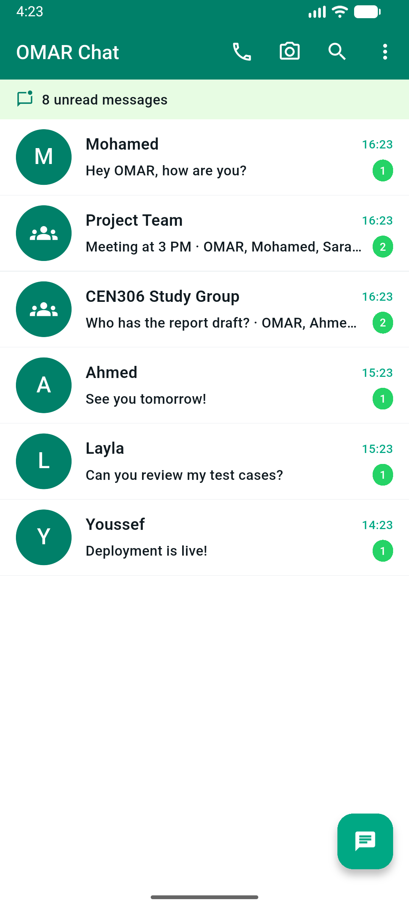  Chat List — unread badges | 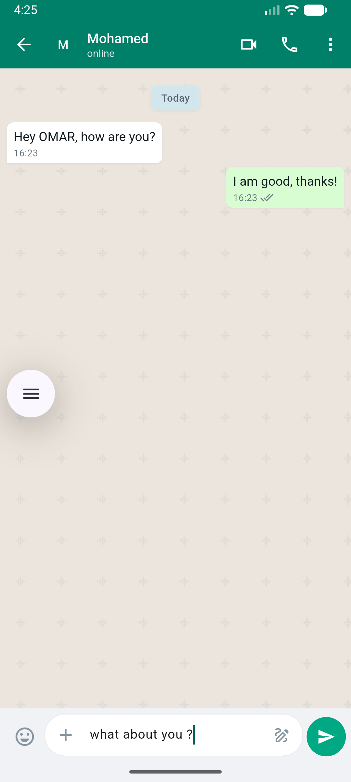  Direct Chat — Mohamed
Chat List shows direct and group chats with unread badges. Direct Chat supports text, attachments, emoji, and voice.
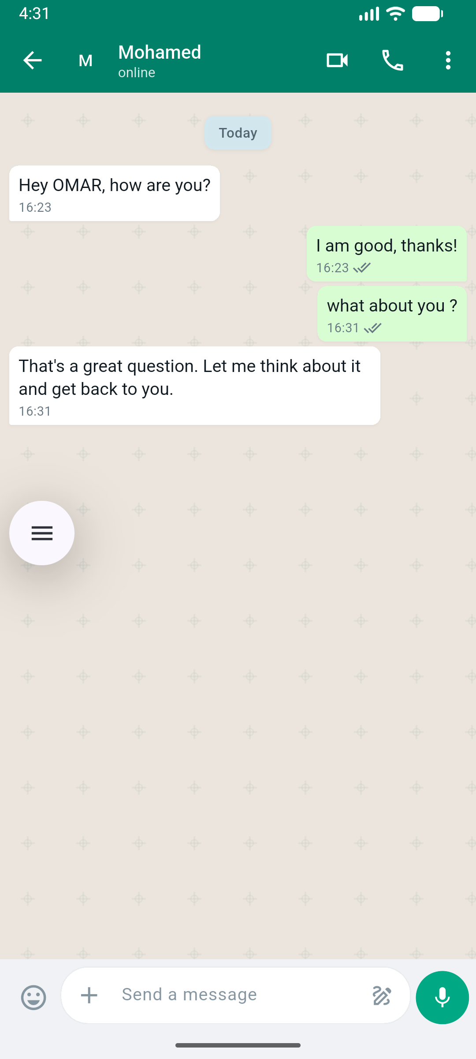  Simulated contextual reply | 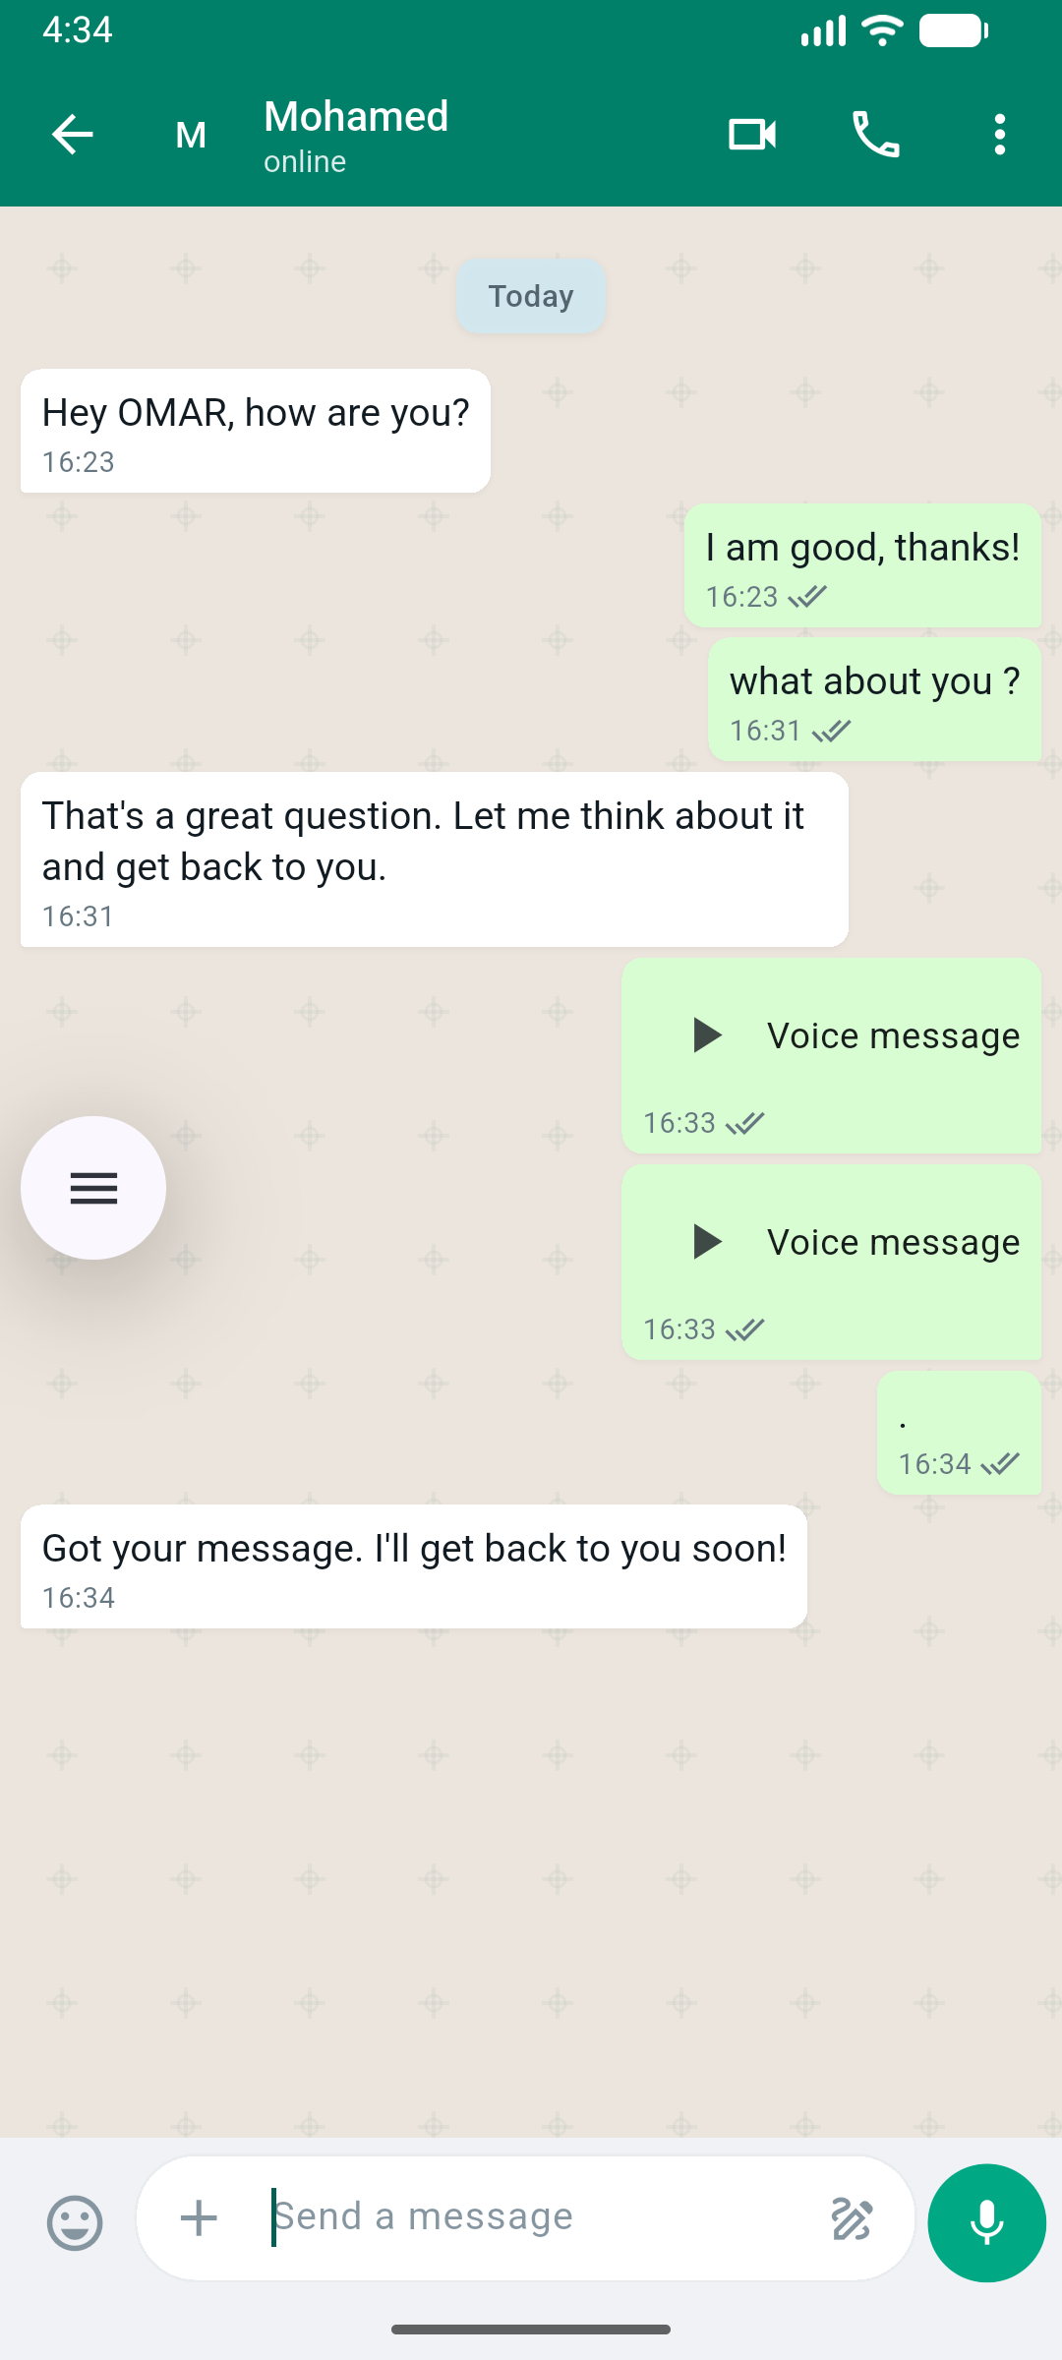  Voice messages
ReceiveMessageUseCase triggers sound + TTS on incoming messages. Voice messages use record + just_audio packages.
4.3.2 Simulated Calls
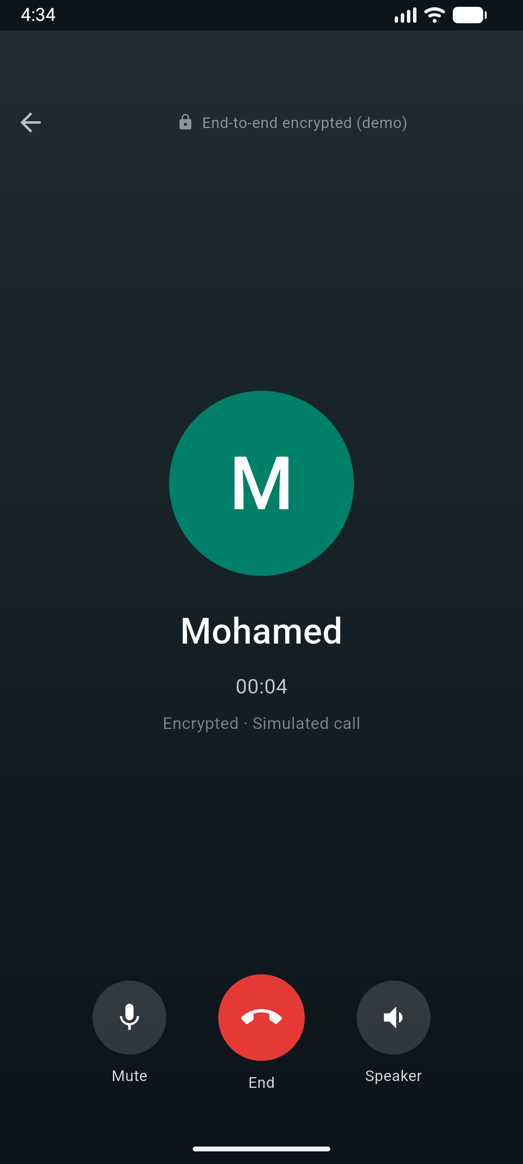  Voice call UI | 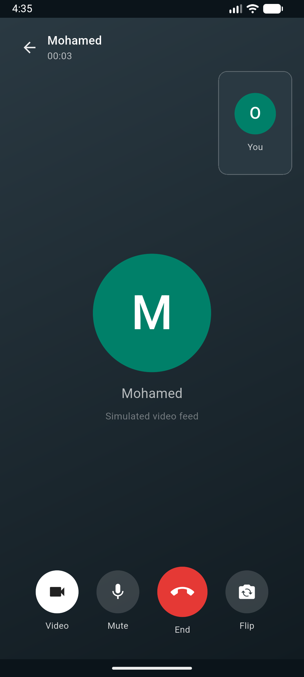  Video call UI
4.3.3 Block & Unblock
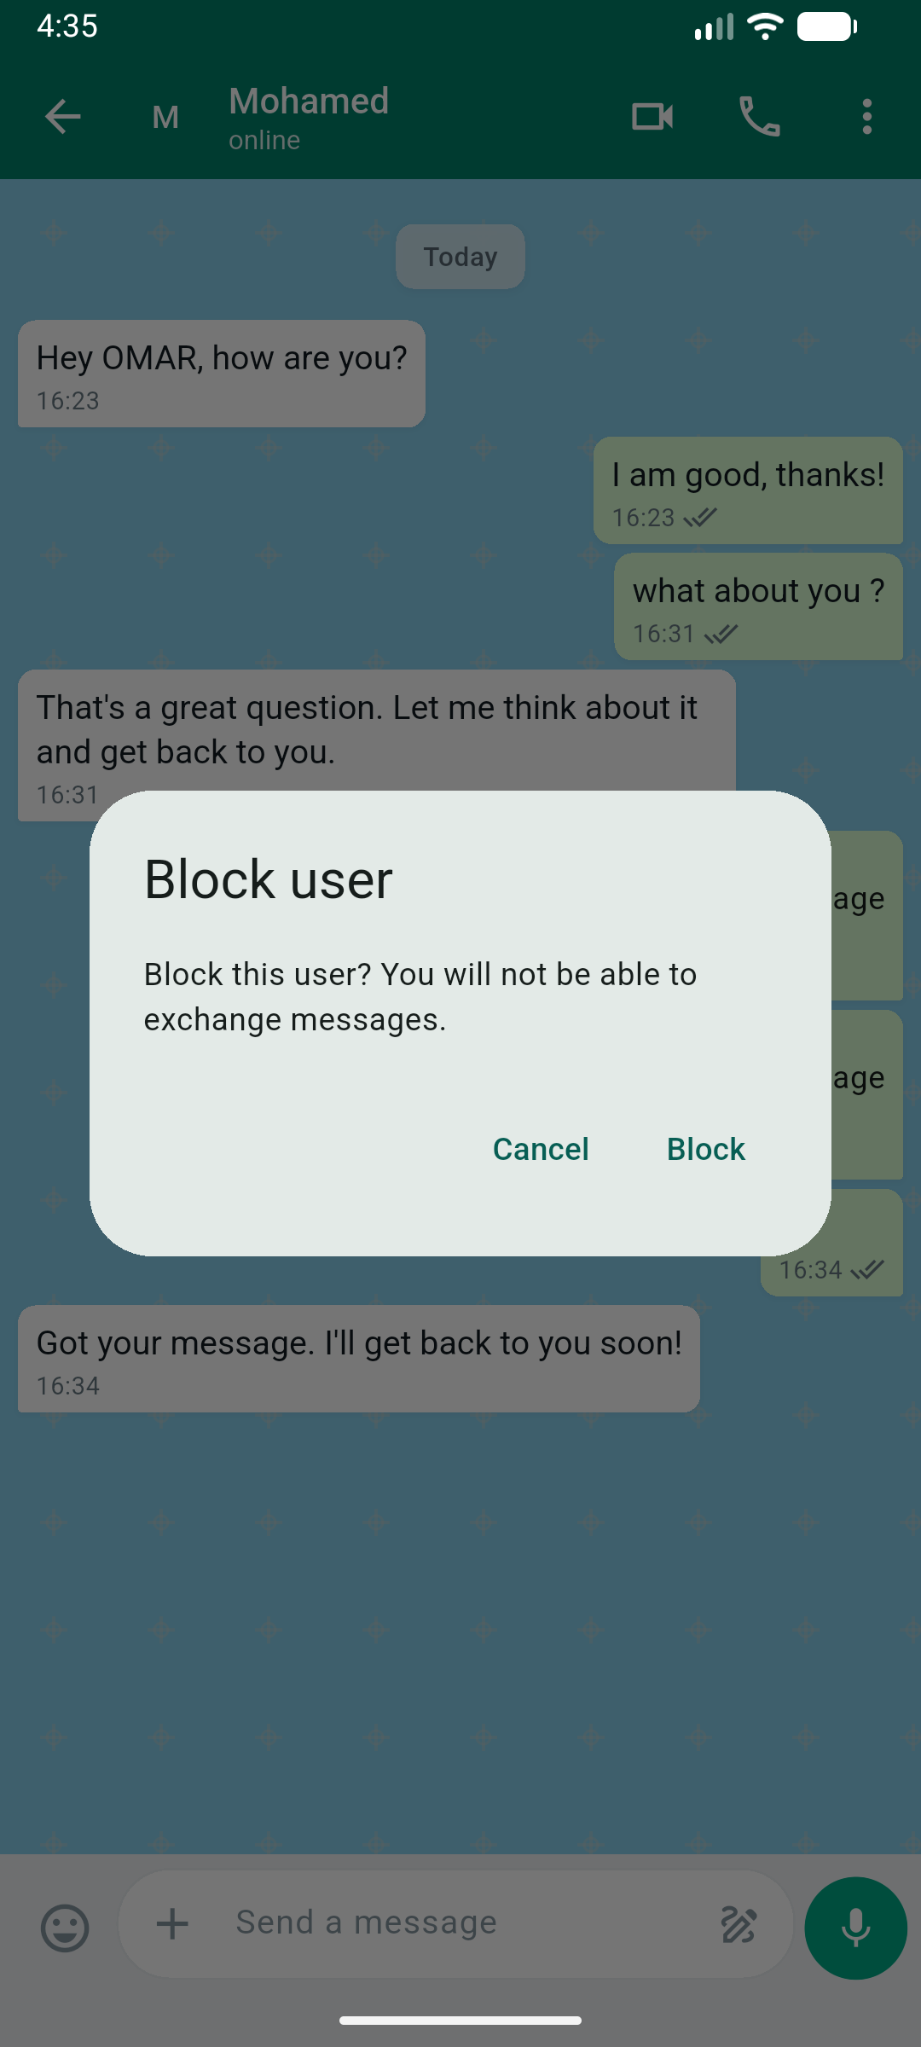  Block confirmation | 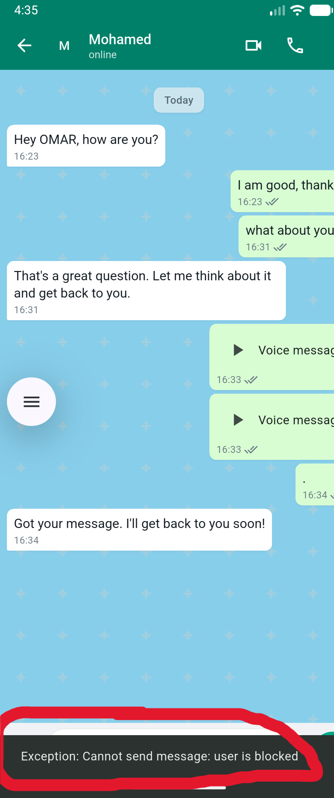  Send blocked error
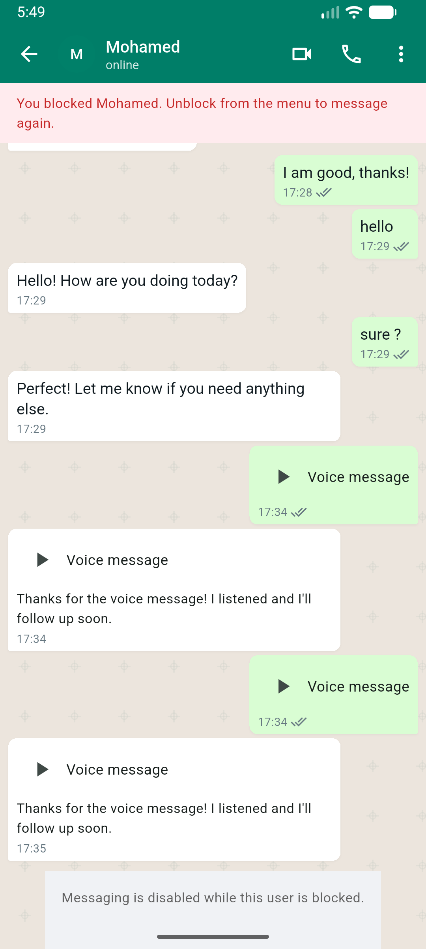  Blocked banner + disabled input | 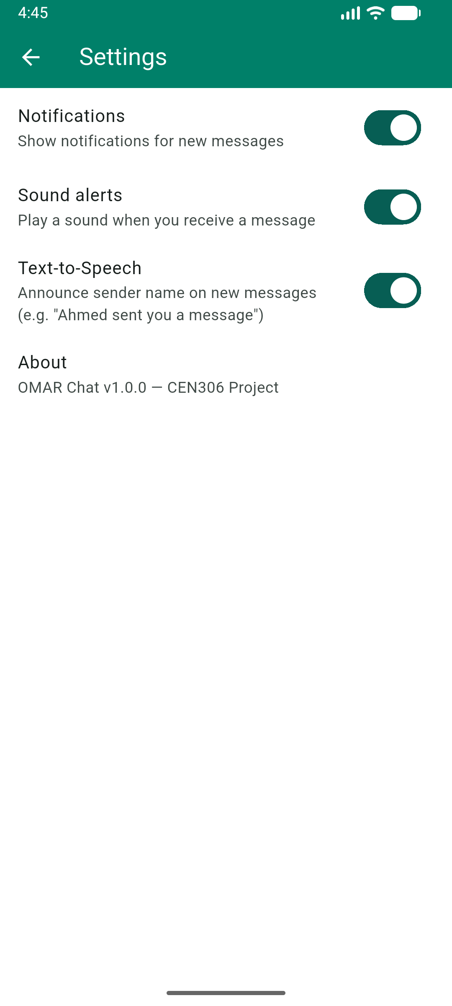  Settings toggles
Block applies to one user only in direct chats. Unblock restores messaging from Chat Detail menu.
4.3.4 Profile & Status
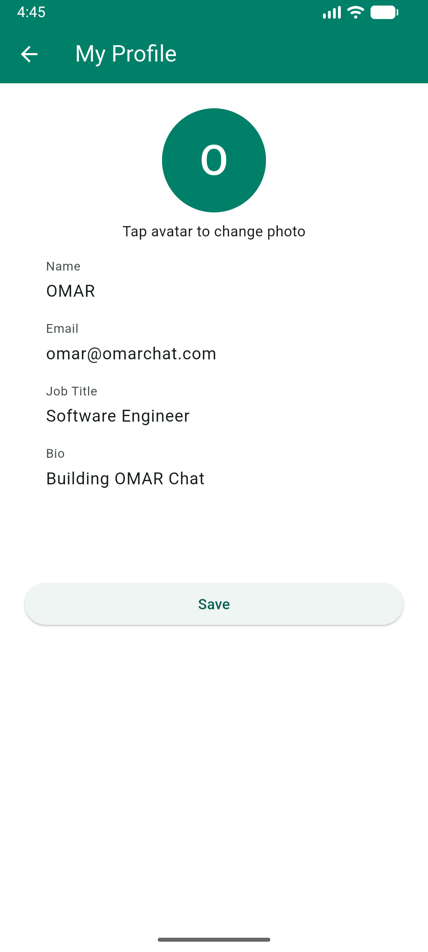  Profile edit screen | 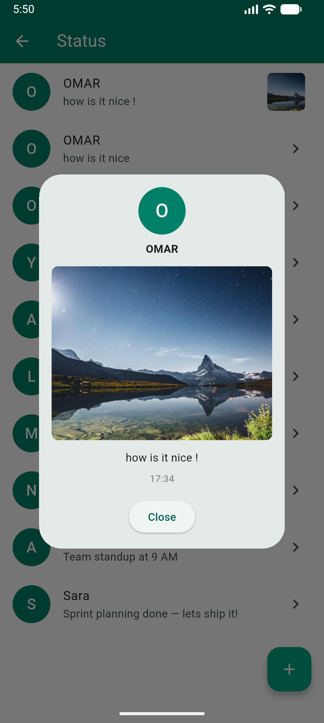  Status — landscape photo
4.3.5 Search
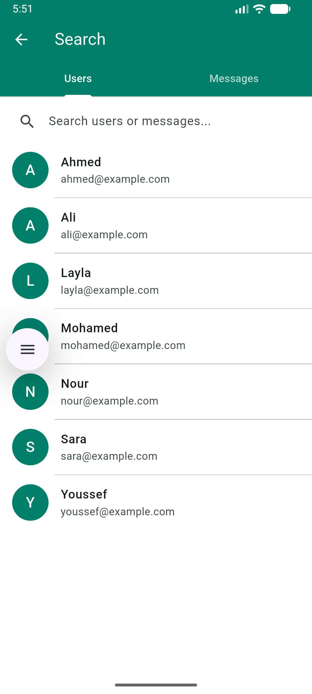  Search — Users tab | 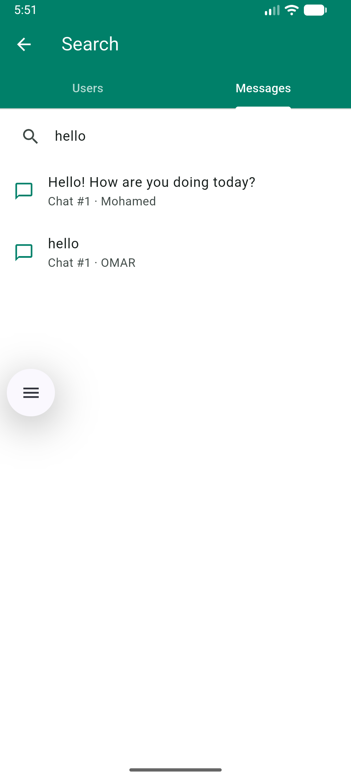  Search — Messages tab
4.3.6 Group Chat Features
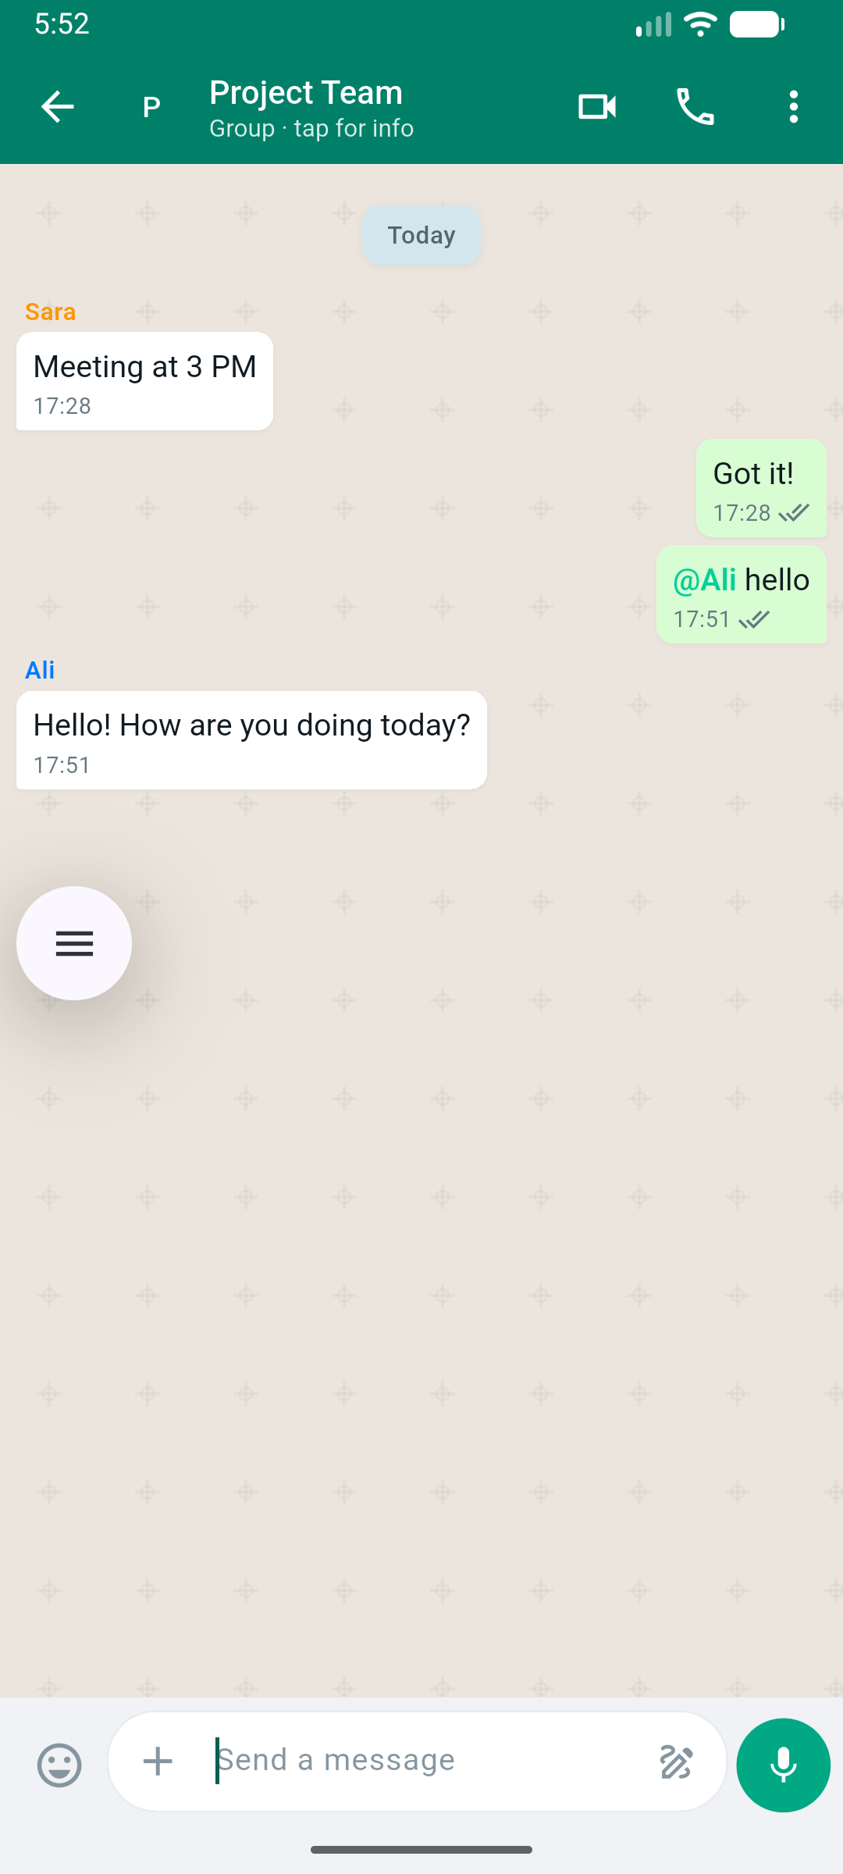  Group chat + @mention reply | 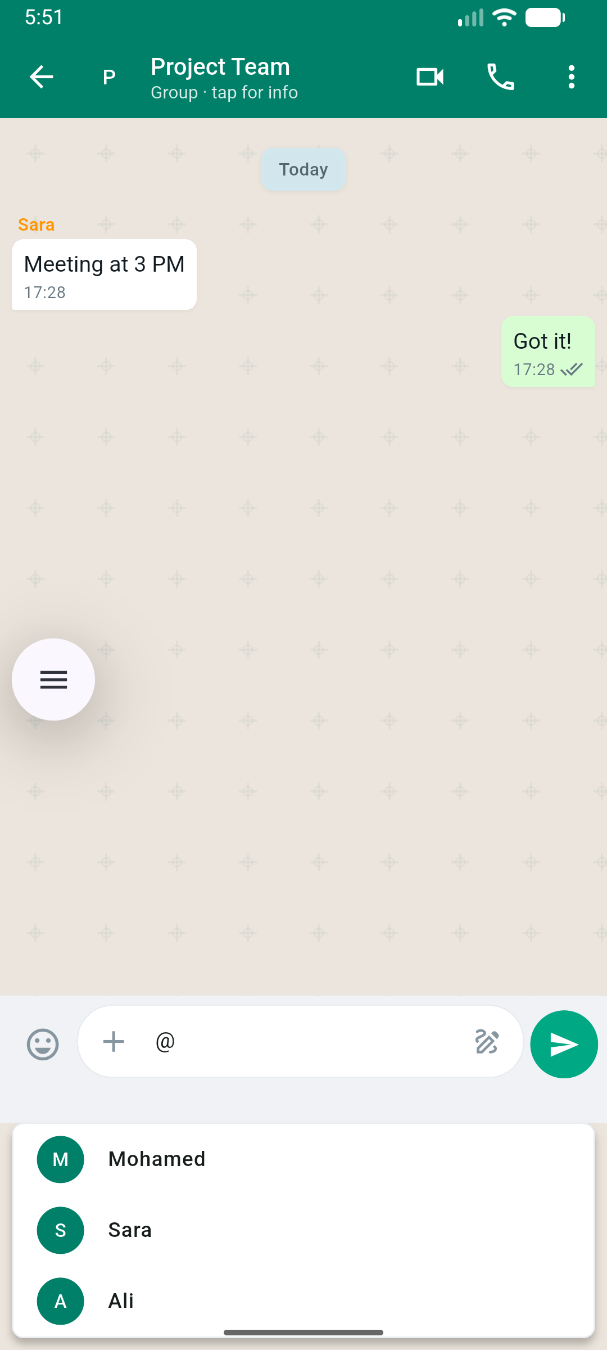  @Mention picker
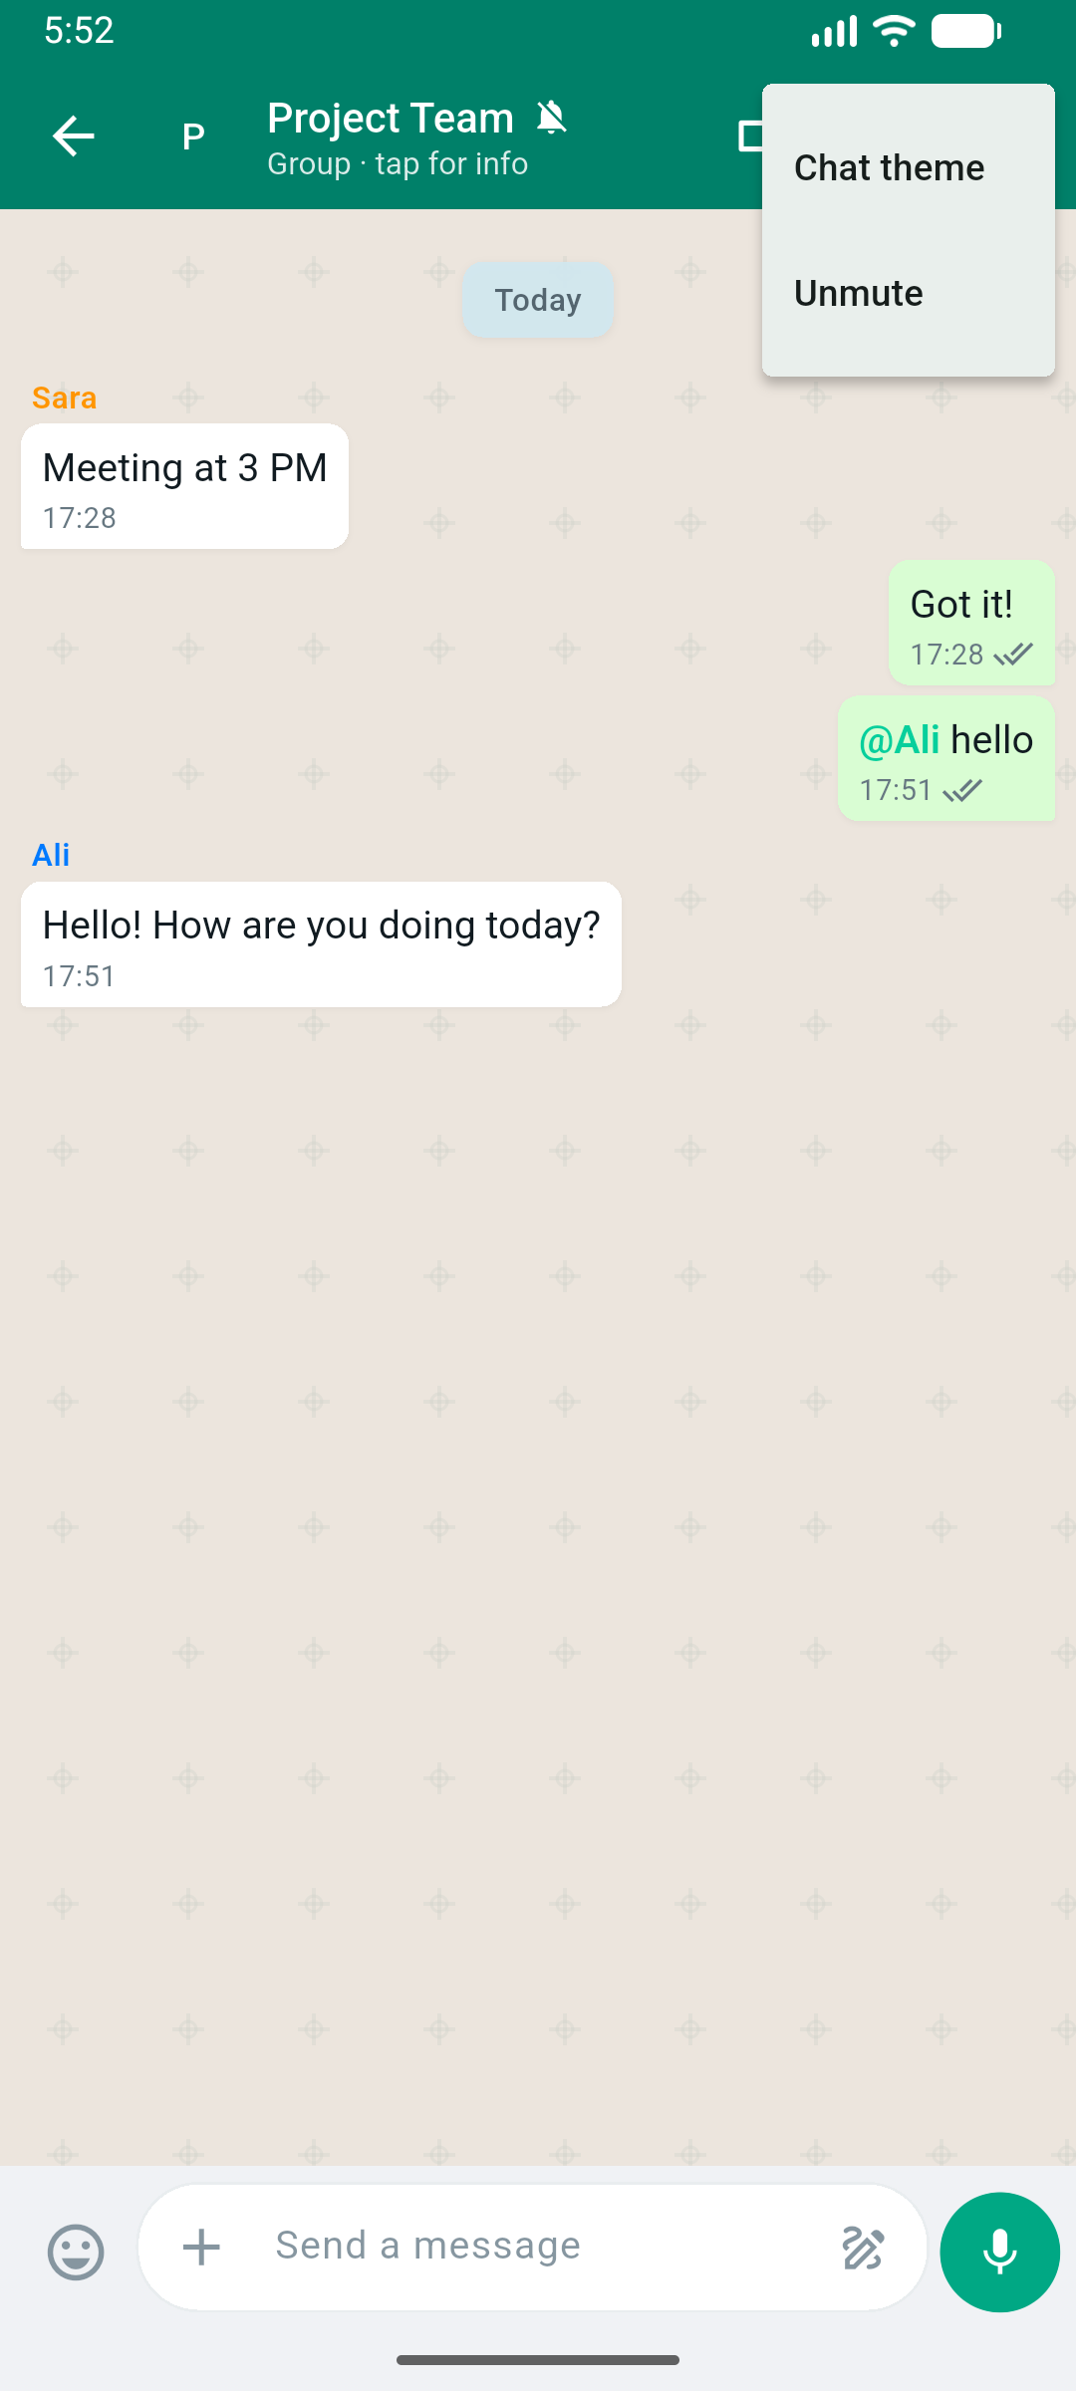  Mute & chat theme | 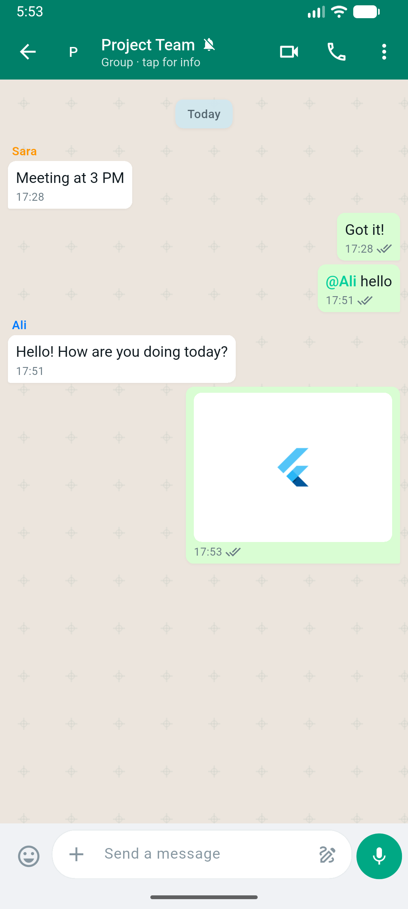  Image attachment
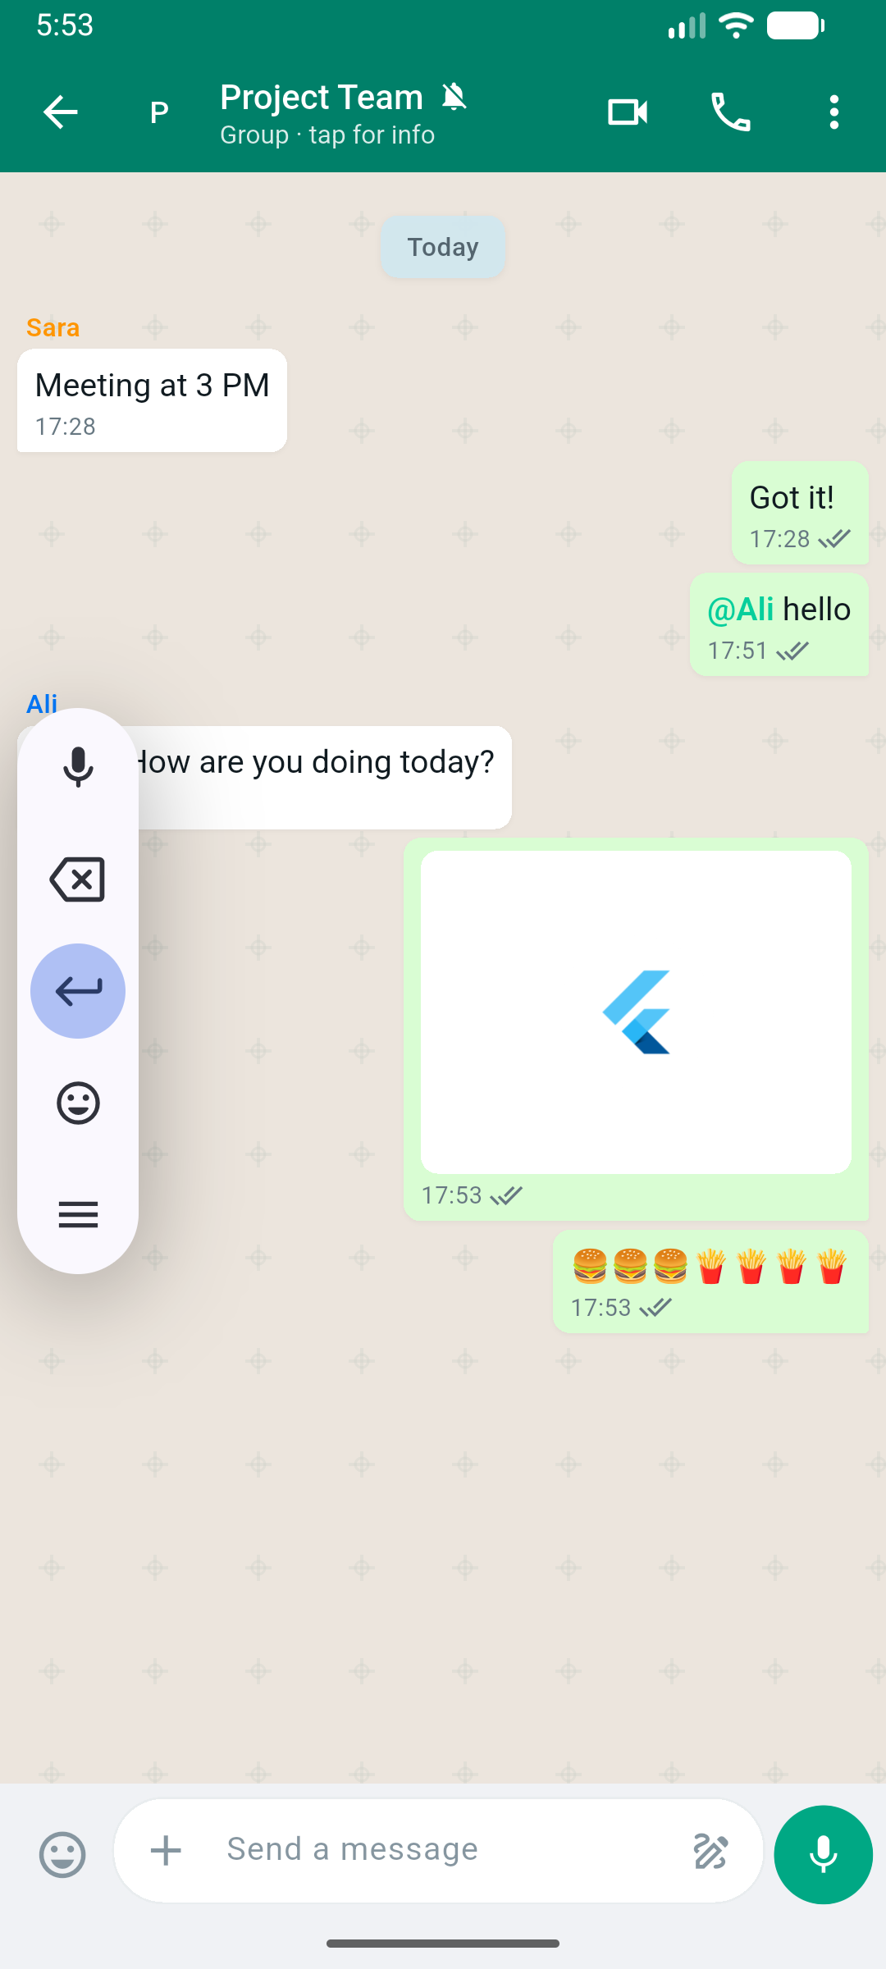  Emoji messages | 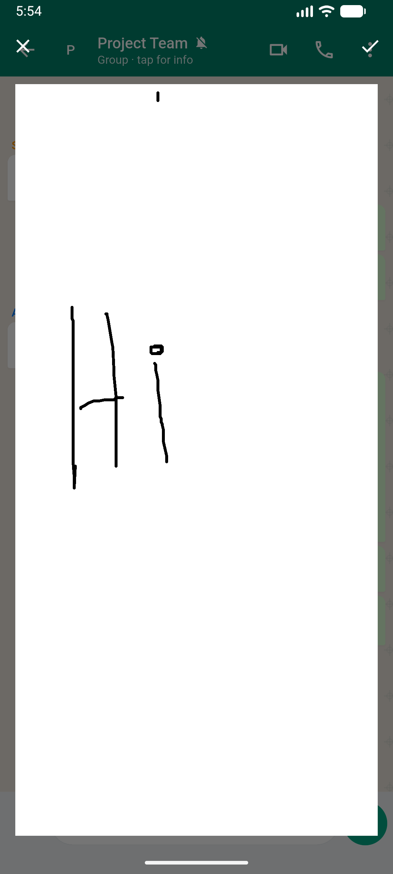  Drawing board
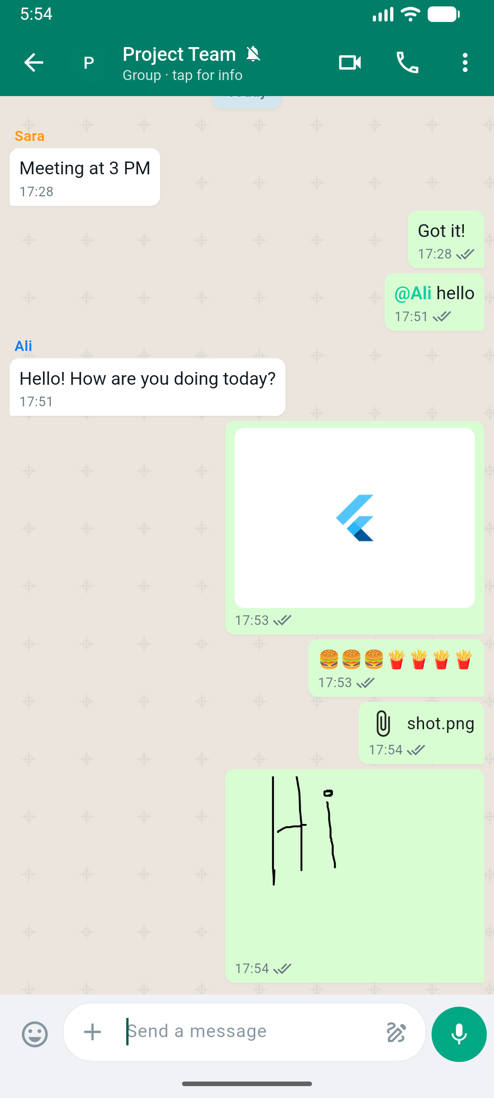
Group — images, emoji, file, drawing combined
4.4 Latest Feature — Create Multi-User Group
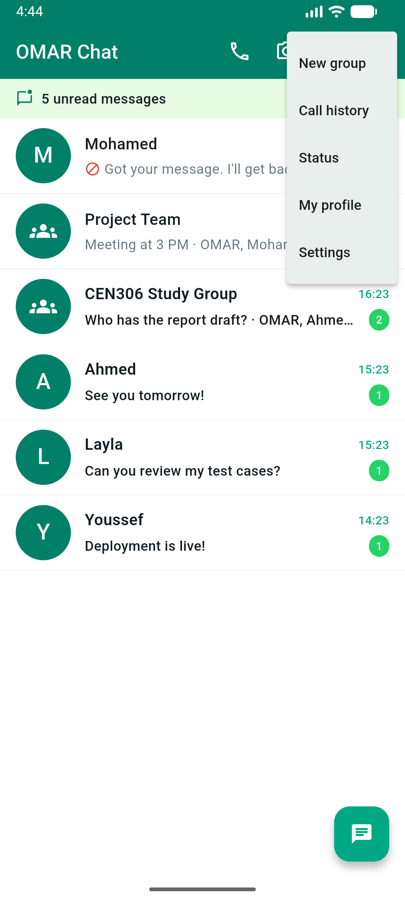
New group entry — Chat List menu
The latest feature lets OMAR create a new group with multiple users. Open Chat List → overflow menu → **New group** (or the **New group** FAB). On the Create Group screen: enter a group name, select one or more contacts (OMAR is added automatically as admin), then tap **Create Group**. GroupDao saves the chat, members, and unread rows to SQLite (sqflite on mobile); the new group appears on the chat list and opens immediately. The menu screenshot also shows Mohamed marked as blocked on the chat list — block applies only to direct chat, not group creation.
Screenshot file | Feature demonstrated
01_chat_list.png | Chat list & unread badges
02_direct_chat.png | Direct messaging
03_direct_reply.png | Simulated reply + sound/TTS
04_voice_messages.png | Voice messages
05_voice_call.png / 06_video_call.png | Simulated calls
07–08, 12_*.png | Block / unblock one user
09_chat_menu_new_group.png | Create multi-user group (entry)
10_settings.png | Notifications, sound, TTS toggles
11_profile.png | Profile editing
13_status_landscape.png | Status with landscape photo
14–15_*.png | User and message search
16–22_*.png | Group @mention, mute, theme, media, emoji, drawing
5. Technical Architecture
5.1 Overall Layered Architecture
OMAR Chat implements strict layered architecture. Dependencies flow in one direction only: UI Layer → Business Layer → Data Layer. The Presentation layer (screens and Cubits) never calls SQL or DAO classes directly. The Business layer (use cases) enforces rules such as block checks, edit windows, and notification logic. The Data layer (DAOs and repositories) handles SQLite persistence via sqflite. Platform services (sound, TTS, media) and shared constants (core/) support all layers but are not substitutes for the three required layers.
Layer | Folder path | Responsibility | Depends on
UI Layer (Presentation) | lib/presentation/ | Screens, widgets, Cubit state — display data and capture input | Business Layer (via use cases)
Business Layer (Domain) | lib/domain/ | Entities and use cases — business rules and validation | Data Layer (via repositories)
Data Layer | lib/data/ | Models, DAO, Repository, SQLite database access | SQLite (sqflite) / JSON fallback
Services (supporting) | lib/services/ | Notifications, sound, TTS, media, file storage | Called by Business/UI — not a replacement layer
Core (supporting) | lib/core/ | Constants, theme, routes, utilities | Shared by all layers
5.2 Project Structure — Folder Structure
The three rubric-required layers are mapped to three separate top-level folders under lib/. No screen file exists inside domain/ or data/, and no DAO or SQL code exists inside presentation/. The table below defines this separation explicitly before the full folder tree.
Required layer | Physical folder | Subfolders / key files | What belongs here
UI Layer (Presentation Layer) | lib/presentation/ | screens/ (11 screens), widgets/ (19 widgets), state/ (7 Cubits) | All Flutter UI: layouts, navigation, user input, BlocBuilder rebuilds. Must NOT contain SQL, DAO, or repository code.
Business Layer (Domain Layer) | lib/domain/ | entities/ (6 entities), usecases/ (11 use cases) | Pure business logic: SendMessage, BlockUser, CreateGroup, etc. Must NOT render widgets or access the database directly.
Data Layer | lib/data/ | models/ (11 models), dao/ (9 DAOs), repositories/ (8 repositories), database/ | Persistence only: CRUD via DAO classes, entity mapping via repositories, sqflite in InMemoryStore. Must NOT contain UI widgets.
Figure 1 — Complete lib/ folder tree with layer labels. Each entry shows the file role. Source code is not included in this report; only structure and responsibilities are documented.
lib/
├── main.dart — App entry point; initializes database and runs OmarChatApp
├── app.dart — MaterialApp, named routes, MultiBlocProvider, lifecycle save
│
├── presentation/ ═══ UI LAYER (Presentation Layer) ═══
│ ├── screens/ — Full-page UI (11 screens); one folder per screen
│ │ ├── splash/ — SplashScreen: branding, auto-navigate to Chat List
│ │ ├── chat_list/ — ChatListScreen: unread badges, New group FAB, navigation hub
│ │ ├── chat_detail/ — ChatDetailScreen: messaging, voice, @mentions, block menu
│ │ ├── create_group/ — CreateGroupScreen: group name + multi-select members
│ │ ├── search/ — SearchScreen: Users tab and Messages tab
│ │ ├── profile/ — ProfileScreen: edit profile, gallery/default landscape photo
│ │ ├── settings/ — SettingsScreen: notifications, sound, TTS toggles
│ │ ├── user_detail/ — UserDetailScreen: contact info, call, block/unblock
│ │ ├── status/ — StatusScreen: 24h text/photo status posts
│ │ ├── call/ — CallScreen: simulated voice/video call UI
│ │ └── call_history/ — CallHistoryScreen: past calls list
│ ├── widgets/ — Reusable UI components (ChatTile, MessageBubble, …)
│ │ ├── chat_tile.dart — Chat list row with unread badge
│ │ ├── message_bubble.dart — Sent/received message bubble
│ │ ├── chat_input_bar.dart — Text input, emoji, attach, mic, draw buttons
│ │ ├── voice_message_widget.dart — Voice bubble with play/stop
│ │ ├── mention_picker.dart — @Mention member picker (group chats)
│ │ └── … (14 more widgets) — EmojiPicker, DrawingBoard, UnreadBadge, etc.
│ └── state/ — Cubit state management (flutter_bloc)
│ ├── chat_list_cubit.dart — Chat list loading and refresh
│ ├── chat_detail_cubit.dart — Messages, send, edit, delete
│ ├── group_cubit.dart — Create group form state
│ ├── search_cubit.dart — User and message search
│ ├── profile_cubit.dart — Profile edit state
│ ├── settings_cubit.dart — Settings toggles state
│ └── call_history_cubit.dart — Call history list state
│
├── domain/ ═══ BUSINESS LAYER (Domain Layer) ═══
│ ├── entities/ — Pure Dart domain objects (no Flutter imports)
│ │ ├── user.dart — User entity (name, email, avatar, online)
│ │ ├── chat.dart — Chat entity (direct/group, last message)
│ │ ├── message.dart — Message entity (content, type, reply, flags)
│ │ ├── group.dart — Group member entity
│ │ ├── call_record.dart — Call history record entity
│ │ └── call_session.dart — Active call session entity
│ └── usecases/ — Single-responsibility business operations (11 use cases)
│ ├── send_message_usecase.dart — Send text/voice; block check (direct only)
│ ├── receive_message_usecase.dart — Incoming message; sound + TTS + auto-reply
│ ├── edit_message_usecase.dart — Edit within 10-minute window
│ ├── delete_message_usecase.dart — Delete for me / for all (5 min)
│ ├── block_user_usecase.dart — Block/unblock one user pair
│ ├── create_group_usecase.dart — Validate name + members; create group
│ ├── create_chat_usecase.dart — Open or create direct chat
│ ├── mute_chat_usecase.dart — Mute/unmute per chat
│ ├── search_messages_usecase.dart — Global message content search
│ ├── unread_counter_usecase.dart — Mark chat read; update badges
│ └── save_call_usecase.dart — Record simulated call to history
│
├── data/ ═══ DATA LAYER ═══
│ ├── models/ — Database mapping objects (toMap / fromMap)
│ │ ├── user_model.dart — users table mapping
│ │ ├── chat_model.dart — chats table mapping
│ │ ├── message_model.dart — messages table mapping
│ │ ├── group_model.dart — chat_members table mapping
│ │ ├── attachment_model.dart — attachments table mapping
│ │ ├── status_model.dart — statuses table mapping
│ │ ├── unread_counter_model.dart — unread_counts table mapping
│ │ └── … (4 more models) — blocked_user, muted_chat, theme, call_record
│ ├── dao/ — Data Access Objects — CRUD per SQLite table (9 DAOs)
│ │ ├── user_dao.dart — users: getAll, getById, update, search
│ │ ├── chat_dao.dart — chats + chat_members: query(), getChatsForUser
│ │ ├── message_dao.dart — messages: insert, getByChatId, search
│ │ ├── group_dao.dart — createGroup, getMembers, unread init
│ │ ├── unread_dao.dart — unread_counts: increment, reset, getTotal
│ │ ├── settings_dao.dart — blocked_users, muted_chats, theme_settings
│ │ ├── status_dao.dart — statuses: insert, getActive, deleteExpired
│ │ ├── attachment_dao.dart — attachments: insert, getByMessageId
│ │ └── call_dao.dart — call_history: insert, getAll
│ ├── repositories/ — Aggregate DAOs; map models → domain entities (8 repos)
│ │ ├── user_repository.dart — UserDao → User entity
│ │ ├── chat_repository.dart — ChatDao + UnreadDao → Chat list with badges
│ │ ├── message_repository.dart — MessageDao + AttachmentDao → Message entity
│ │ ├── group_repository.dart — GroupDao → group creation
│ │ ├── settings_repository.dart — SettingsDao → block/mute/theme
│ │ ├── status_repository.dart — StatusDao → status posts
│ │ ├── call_repository.dart — CallDao → call history
│ │ └── attachment_repository.dart— AttachmentDao → file metadata
│ └── database/ — SQLite connection and unified store API
│ ├── app_database.dart — Singleton; exposes InMemoryStore
│ └── in_memory_store.dart — sqflite on Android/iOS; JSON fallback on web
│
├── services/ — Platform services (NOT a rubric layer; supports UI/Business)
│ ├── persistence_service.dart — JSON save/load fallback for web/desktop
│ ├── notification_sound_service.dart — Alert tone on incoming messages
│ ├── speech_service.dart — Text-to-speech: "{Name} sent you a message"
│ ├── local_notification_service.dart — Android/iOS push notifications
│ ├── media_service.dart — Voice record (record) and playback (just_audio)
│ ├── auto_reply_service.dart — Contextual text/voice simulated replies
│ └── file_storage.dart — Cross-platform file read/write
│
└── core/ — Shared constants and utilities
├── constants/db_constants.dart — SQLite CREATE TABLE statements (11 tables)
├── constants/app_routes.dart — Named route strings
├── constants/app_assets.dart — Bundled mountain_landscape.png path
├── theme/app_theme.dart — WhatsApp-style green theme
└── utils/ — Date formatting, validators, route args
Figure 1. Simplified project folder structure. The three required layers — UI Layer (presentation/), Business Layer (domain/), and Data Layer (data/) — are physically separated. Screens and Cubits live only in presentation/; use cases and entities live only in domain/; DAOs, repositories, and models live only in data/.
Layer transition | Allowed call direction | Example in OMAR Chat
UI → Business | Screen/Cubit calls Use Case | ChatDetailCubit → SendMessageUseCase.execute()
Business → Data | Use Case calls Repository | SendMessageUseCase → MessageRepository.send()
Data → SQLite | Repository calls DAO; DAO calls InMemoryStore | MessageDao.insert() → store.insert("messages", …) → sqflite
NOT allowed | UI → DAO or UI → SQL directly | No screen imports message_dao.dart
5.3 Responsibilities of Each Layer
Layer | Key responsibility | Must NOT do
UI Layer (presentation/) | Render screens/widgets; Cubits call use cases; BlocBuilder rebuilds UI | Import or call DAO, Repository, or SQL directly
Business Layer (domain/) | Validate rules (block, edit window, group name); orchestrate repositories | Build widgets; write SQL; play sounds directly
Data Layer (data/) | DAO CRUD on SQLite tables; Repository maps Model → Entity | UI layout; business validation; notification display
Services (lib/services/) | Platform APIs: sound, TTS, notifications, voice record, files | Replace Business or Data layer responsibilities
Core (lib/core/) | Shared constants (db_constants, routes, theme colors) | Store business logic or database queries

6. Data Layer: SQLite, DAO, and Repository
6.1 SQLite Database Design (sqflite)
OMAR Chat uses the sqflite package on Android/iOS. Database file: omar_chat.db. Table CREATE statements are defined in lib/core/constants/db_constants.dart and executed in InMemoryStore._initSqlite() on first launch. DAO classes perform INSERT, SELECT, UPDATE, and DELETE through a unified store API. On web, the same DAO/Repository code uses a JSON-backed fallback.
Table | Purpose
users | Accounts, profile, online status
chats | Direct/group threads, last message
chat_members | User–chat membership
messages | Content, type, reply, edit/delete flags
attachments | Files linked to messages
statuses | 24h status posts
theme_settings | Per-chat wallpaper
blocked_users / muted_chats / unread_counts / call_history | Settings and call records
6.2 DAO Design
Nine DAO classes encapsulate all SQL access. Each DAO calls InMemoryStore.insert(), query(), update(), updateWhere(), or deleteWhere() — never raw SQL from UI or use cases. ChatDao and UnreadDao use the unified query() API instead of direct list access.
DAO class | Table(s) | Key methods | CRUD
UserDao | users | getAll, getById, update, searchByName | SELECT, UPDATE
ChatDao | chats, chat_members | insert, getById, getChatsForUser, findDirectChat, updateLastMessage | INSERT, SELECT, UPDATE
MessageDao | messages | insert, getByChatId, getById, update, deleteWhere, searchContent | INSERT, SELECT, UPDATE, DELETE
GroupDao | chats, chat_members, unread_counts | createGroup, getMembers, addMember | INSERT, SELECT
AttachmentDao | attachments | insert, getByMessageId | INSERT, SELECT
StatusDao | statuses | insert, getActiveForUser, deleteExpired | INSERT, SELECT, DELETE
SettingsDao | blocked_users, muted_chats, theme_settings | blockUser, unblockUser, isMuted, getTheme | INSERT, SELECT, DELETE
UnreadDao | unread_counts | increment, reset, getCount, getTotalForUser | INSERT, UPDATE, SELECT
CallDao | call_history | insert, getAll, getByChatId | INSERT, SELECT
6.3 Repository Design
Eight repository classes sit between use cases and DAOs. Each repository maps data models to domain entities and may combine multiple DAOs. Screens and Cubits call use cases only; use cases call repositories — never DAOs directly from the UI layer.
Repository | DAO(s) used | Domain purpose
UserRepository | UserDao | User profiles, contact search
ChatRepository | ChatDao, GroupDao, UnreadDao, SettingsDao, UserDao | Chat list, unread badges, last message
MessageRepository | MessageDao, AttachmentDao, UserDao | Send/receive messages with reply preview and attachments
GroupRepository | GroupDao, ChatDao | Create group, list members
AttachmentRepository | AttachmentDao | File/image attachment metadata
StatusRepository | StatusDao, UserDao | 24h status posts with user info
SettingsRepository | SettingsDao | Block/unblock, mute, per-chat themes
CallRepository | CallDao | Simulated call history records
Model class | SQLite table | Entity mapped to
UserModel | users | User
ChatModel | chats | Chat
MessageModel | messages | Message
GroupModel / ChatMemberModel | chat_members | GroupMember
AttachmentModel | attachments | Attachment
StatusModel | statuses | Status
BlockedUserModel / MutedChatModel / ThemeSettingModel | blocked_users, muted_chats, theme_settings | Block/Mute/Theme settings
UnreadCounterModel | unread_counts | Unread count per chat
CallRecordModel | call_history | CallRecord
6.4 Data Flow Example — Incoming Message
Step | Layer | Action
1 | ReceiveMessageUseCase | Insert message; increment unread
2 | NotificationSoundService | Play alert tone
3 | LocalNotificationService | Show push notification (mobile)
4 | SpeechService | Speak "{Name} sent you a message"
5 | ChatDetailCubit | Refresh UI message list
6.5 Data Persistence Across App Restarts
On Android/iOS, sqflite opens omar_chat.db and persists every INSERT/UPDATE/DELETE immediately through InMemoryStore dual-write (in-memory lists + SQLite). On web and desktop without sqflite, the same DAO/Repository API serializes to JSON via PersistenceService. OmarChatApp registers WidgetsBindingObserver to flush JSON on app pause. On first launch, seed data is inserted once. This preserves messages, blocks, mutes, statuses, profile avatar paths, unread counts, call history, and newly created groups across restarts.
Stored data | Persistence mechanism
Messages, chats, attachments | SQLite (sqflite) on mobile; JSON file on web/desktop fallback
Blocked users, muted chats, themes | Same SQLite tables / JSON snapshot
User profile & avatar path | users table / JSON snapshot
Notification/sound/TTS toggles | SharedPreferences keys
Voice recording files | App documents directory (paths stored in attachments table)
7. Implementation Details
7.1 Flutter Widgets and Screens
The app implements 11 screens and 19+ reusable widgets. ChatDetailScreen integrates ChatInputBar (text, emoji, attach, mic, draw), MentionPicker for groups, block/unblock menu, and blocked-state banner. ProfileScreen and StatusScreen support gallery images and the bundled mountain_landscape.png asset via AppAssets.
Screen | State approach | Primary features demonstrated
Splash | StatefulWidget | Branding splash; auto-navigate to Chat List
Chat List | ChatListCubit + BlocBuilder | Unread badges, block icon, New group FAB, navigation hub
Chat Detail | ChatDetailCubit + StatefulWidget | Messaging, voice, @mentions, block/unblock, themes
Create Group | GroupCubit + StatefulWidget | Name group, multi-select members, Create Group action
Search | SearchCubit + StatefulWidget | Users tab and Messages tab global search
Profile | ProfileCubit + StatefulWidget | Edit profile, gallery photo, default landscape avatar
Settings | SettingsCubit + StatefulWidget | Notifications, sound alerts, TTS toggles
User Detail | StatefulWidget | View contact, call, message, block/unblock
Status | StatefulWidget + StatusRepository | Text/photo status, default landscape, 24h expiry
Call | StatefulWidget | Simulated voice/video call UI with timer and controls
Call History | CallHistoryCubit + BlocBuilder | Past voice/video calls with missed/outgoing flags
7.2 Navigation and Routing
Named routes in app.dart with RouteSettings arguments. MultiBlocProvider at app root supplies Cubits to all screens.
7.3 State Management
Shared application state uses flutter_bloc Cubits at lib/presentation/state/. Local UI state (text fields, tabs, recording timer, call duration) stays in StatefulWidget screens. Cubits call domain use cases; use cases call repositories. UI rebuilds via BlocBuilder / context.read after each emit.
Cubit | Screen(s) | Use case(s) called
ChatListCubit | Chat List | LoadChats, block refresh
ChatDetailCubit | Chat Detail | SendMessage, ReceiveMessage, EditMessage, DeleteMessage
GroupCubit | Create Group | CreateGroupUseCase
SearchCubit | Search | SearchUsers, SearchMessages
ProfileCubit | Profile | UpdateProfile
SettingsCubit | Settings | UpdateSettings
CallHistoryCubit | Call History | LoadCallHistory
StatefulWidget screen | Local state managed
SplashScreen | Animation timer, navigation delay
ChatDetailScreen | Input focus, emoji panel, mention picker visibility
CreateGroupScreen | Group name field, member checkbox selection
SearchScreen | Tab controller (Users / Messages)
CallScreen | Call timer, mute/end button state
StatusScreen | Gallery picker, caption field
7.4 Validation, Error Handling, and User Feedback
Situation | Handling | User feedback
Empty message | Ignored in sendText | No action
Blocked user (direct) | SendMessageUseCase throws | Error snackbar; input disabled
Unblock user | SettingsDao removes block row | Banner removed; messaging enabled
Voice permission denied | startRecording returns false | Mic button inactive
Create group missing name/members | CreateGroupUseCase / GroupCubit validation | Helper text + disabled Create button
Muted chat | Skip notifications | Mute icon on chat tile
7.5 Important Code Files (no source code in report)
File | Purpose
persistence_service.dart | JSON save/load fallback for web and desktop
in_memory_store.dart | Unified store: sqflite on mobile, JSON fallback; dual-write on CRUD
app_assets.dart | Bundled mountain_landscape.png path for profile/status
block_user_usecase.dart | Block/unblock single user pair
settings_dao.dart | hasBlocked(), isBlocked(), duplicate block prevention
receive_message_usecase.dart | Incoming alerts; voice/text simulated replies
send_message_usecase.dart | Send with block check (direct chats only)
auto_reply_service.dart | generateVoiceReply() for contextual voice captions
media_service.dart | Voice recording (record) and playback (just_audio)
notification_sound_service.dart | Plays message_notification.wav
create_group_usecase.dart | Validates group name and member list (OMAR + ≥1 contact)
group_dao.dart | Inserts group chat, chat_members, and unread_counts rows
create_group_screen.dart | UI: name field, member checkboxes, Create action
7.6 Voice Message Implementation
Voice messages use the record package (AAC .m4a) saved to the app documents folder. Attachments link file paths in the attachments table. VoiceMessageWidget plays audio via just_audio. After OMAR sends a voice message, ReceiveMessageUseCase simulates a contextual voice reply.

Voice messages in direct chat

Contextual text reply after send
Step | Component | Action
1 | ChatInputBar | User taps mic to start/stop recording
2 | MediaService | Saves .m4a to app documents directory
3 | SendMessageUseCase | Inserts message type voice + attachment row
4 | ReceiveMessageUseCase | Simulates peer voice reply with caption
5 | VoiceMessageWidget | Play/stop toggle for sender and receiver
7.7 Block and Unblock Implementation
Blocking stores a directed pair in blocked_users. Block check applies to direct chats only. Unblock removes the row and restores messaging.

Block user confirmation

Blocked banner and disabled input
Rule | Implementation
Block one user only | blockUser() inserts single pair; no global flag
Prevent duplicate blocks | SettingsDao checks existing row before insert
Group chat unaffected | Block check skipped when chat_type is group
Restore messaging | unblockUser() deletes pair; ChatListCubit refreshed
7.8 Profile Photo and Status Photo
Gallery picker and bundled mountain_landscape.png via AppAssets. Profile and Status screens support both options.

Profile screen

Status with mountain landscape photo
7.9 Create Multi-User Group (Latest Feature)
This is the most recently added feature. OMAR can create a brand-new group chat with multiple users without using pre-seeded groups only. Implementation spans CreateGroupScreen (UI), GroupCubit (state), CreateGroupUseCase (business rules), and GroupDao (persistence).

Create Multi-User Group — New group menu entry
Step | User action / component | Result
1 | Chat List → menu **New group** or **New group** FAB | Opens Create Group screen
2 | Enter group name in text field | Create button enabled when name + members set
3 | Check one or more contacts in list | Selected chips shown; OMAR added automatically
4 | Tap **Create** (app bar) or **Create Group** (bottom) | GroupCubit.createGroup() runs
5 | CreateGroupUseCase + GroupDao | New row in chats (type group), chat_members for each user, unread_counts initialized
6 | PersistenceService auto-save | Group survives app restart (SQLite on mobile)
7 | ChatListCubit.loadChats() + navigation | Group on chat list; Chat Detail opens as group chat
Validation rule | Where enforced
Group name required | CreateGroupUseCase, GroupCubit, CreateGroupScreen
At least one other member selected | CreateGroupUseCase (total members ≥ 2 including OMAR)
Broadcast message optional | Separate action — does not replace group creation
7.10 Data Persistence Implementation
InMemoryStore.initialize() opens sqflite on Android/iOS (omar_chat.db) and loads all 11 tables into memory lists for fast query(). Every insert(), update(), and deleteWhere() dual-writes to SQLite. On web or when sqflite is unavailable (desktop fallback), the same API persists to JSON via PersistenceService. OmarChatApp registers WidgetsBindingObserver to flush JSON on app pause/detached. ChatDao and UnreadDao use store.query() for filtered reads — consistent with the DAO pattern required by the rubric.
8. Testing and Quality Assurance
ID | Feature | Expected | Result
T-01 | Send/receive message | Message appears in chat | Pass
T-02 | Sound + TTS | Hear tone + sender announcement | Pass
T-03 | Group @mention | Mentioned user replies | Pass
T-04 | Block user (direct) | Send fails; input disabled; others OK | Pass
T-05 | Unblock user | Messaging restored after unblock | Pass
T-06 | Voice send/receive | Voice bubble + simulated voice reply | Pass
T-07 | Default landscape photo | Profile/status shows bundled image | Pass
T-08 | Data persistence | Data unchanged after app restart | Pass
T-09 | Group chat while user blocked | Group send still works | Pass
T-10 | Create multi-user group | Named group saved; opens in chat list | Pass
T-11 | Windows / Edge / Android | App launches on target platform | Pass
9. Challenges, Design Decisions, and Solutions
9.1 Key Technical Challenges
Challenge | Solution
Data lost on app restart | sqflite dual-write on mobile; JSON fallback on web/desktop
Blocking one user blocked group sends | Block check limited to direct chats only
No unblock UI | Block/Unblock in Chat Detail menu and User Detail screen
sqflite unavailable on web | InMemoryStore with same DAO/Repository API + JSON persistence
Voice reply simulation | Demo voice asset + contextual text caption in reply bubble
Create group button unclear | Dedicated Create action, helper text, New group FAB on Chat List
9.2 Key Design Decisions
Decision | Reason
Cubit over setState | Shared state across 11 screens; testable use cases
Repository pattern | UI never touches SQL; easy storage backend swap
Separate sound + TTS services | Independent toggles in Settings
10. Conclusion and Future Work
10.1 Summary
OMAR Chat meets CEN306 requirements with layered architecture, nine DAO classes, eight repositories, Cubit state management, 11 screens, multi-user group creation, sound/TTS notifications, @mention auto-replies, voice messaging with voice replies, per-user block/unblock, default landscape profile/status photos, and SQLite persistence (sqflite on Android/iOS; JSON fallback on web).
10.2 Future Improvements
Improvement | Approach
Cloud sync | Firebase Firestore + Cloud Messaging
Real calls | WebRTC / Agora SDK
Authentication | Firebase Auth or custom JWT API

11. References
Source | Type | How it was used
Flutter documentation | Official | Widgets, navigation, assets
flutter_bloc | Package | Cubit state management
sqflite | Package | SQLite on mobile
flutter_local_notifications / flutter_tts / just_audio / record | Packages | Alerts, sound, voice record/playback
12. Appendices
Appendix A: Screenshot Index (Manual Captures)
All images from report_assets/screenshots/ — mapped in SCREENSHOT_MAP.md.
Feature | Screenshot file
Chat list | 01_chat_list.png
Direct chat | 02_direct_chat.png
Simulated reply / sound+TTS | 03_direct_reply.png
Voice messages | 04_voice_messages.png
Voice call | 05_voice_call.png
Video call | 06_video_call.png
Block dialog | 07_block_dialog.png
Block send error | 08_block_send_error.png
Create group (menu entry) | 09_chat_menu_new_group.png
Settings | 10_settings.png
Profile | 11_profile.png
Block banner | 12_block_banner.png
Status landscape | 13_status_landscape.png
Search users | 14_search_users.png
Search messages | 15_search_messages.png
@Mention picker | 16_group_mention_picker.png
@Mention reply | 17_group_mention_reply.png
Mute & chat theme | 18_group_mute_theme.png
Group image | 19_group_image.png
Group emoji | 20_group_emoji.png
Drawing board | 21_drawing_board.png
Group attachments | 22_group_attachments.png
Appendix C: Complete Feature List
# | Feature | Description
1 | Direct & group messaging | Text, emoji, reply, edit, delete, attachments, drawing
2 | Voice messages | Record, send, play; simulated voice reply with caption
3 | Sound + TTS notifications | Alert tone + spoken sender name on incoming messages
4 | Group @mention auto-reply | Mentioned members reply contextually
5 | Create multi-user group | Name group, select members, persist and open chat
6 | Block / unblock user | Block one contact; unblock restores messaging
7 | Data persistence | All data saved on close; restored on reopen
8 | Profile photo | Gallery or default mountain landscape asset
9 | Photo/text status | 24h status with gallery or default landscape
10 | Search | Global user and message search
11 | Mute chat | Suppress notifications per chat
12 | Chat themes | Default, Lion, Sea wallpapers
13 | Simulated calls | Voice/video call UI + call history
14 | Unread badges | Per-chat and total unread summary
15 | Layered architecture | UI / Business / Data / Services separation
Appendix B: Repository and Submission Links
Item | Link / note
Source code repository | [Add repository URL]
Demo video | [Add YouTube URL]
Source code zip | lib/ folder + pubspec.yaml only (OMAR_Chat_SourceCode.zip)

